附件二：2018/19年度爱尔兰互换奖学金申请表

Government of Ireland International Scholarship
Scolaireachtaí Idirnáisiúnta Mhalartaithe Rialtais na hÉireann

Application Form 2018

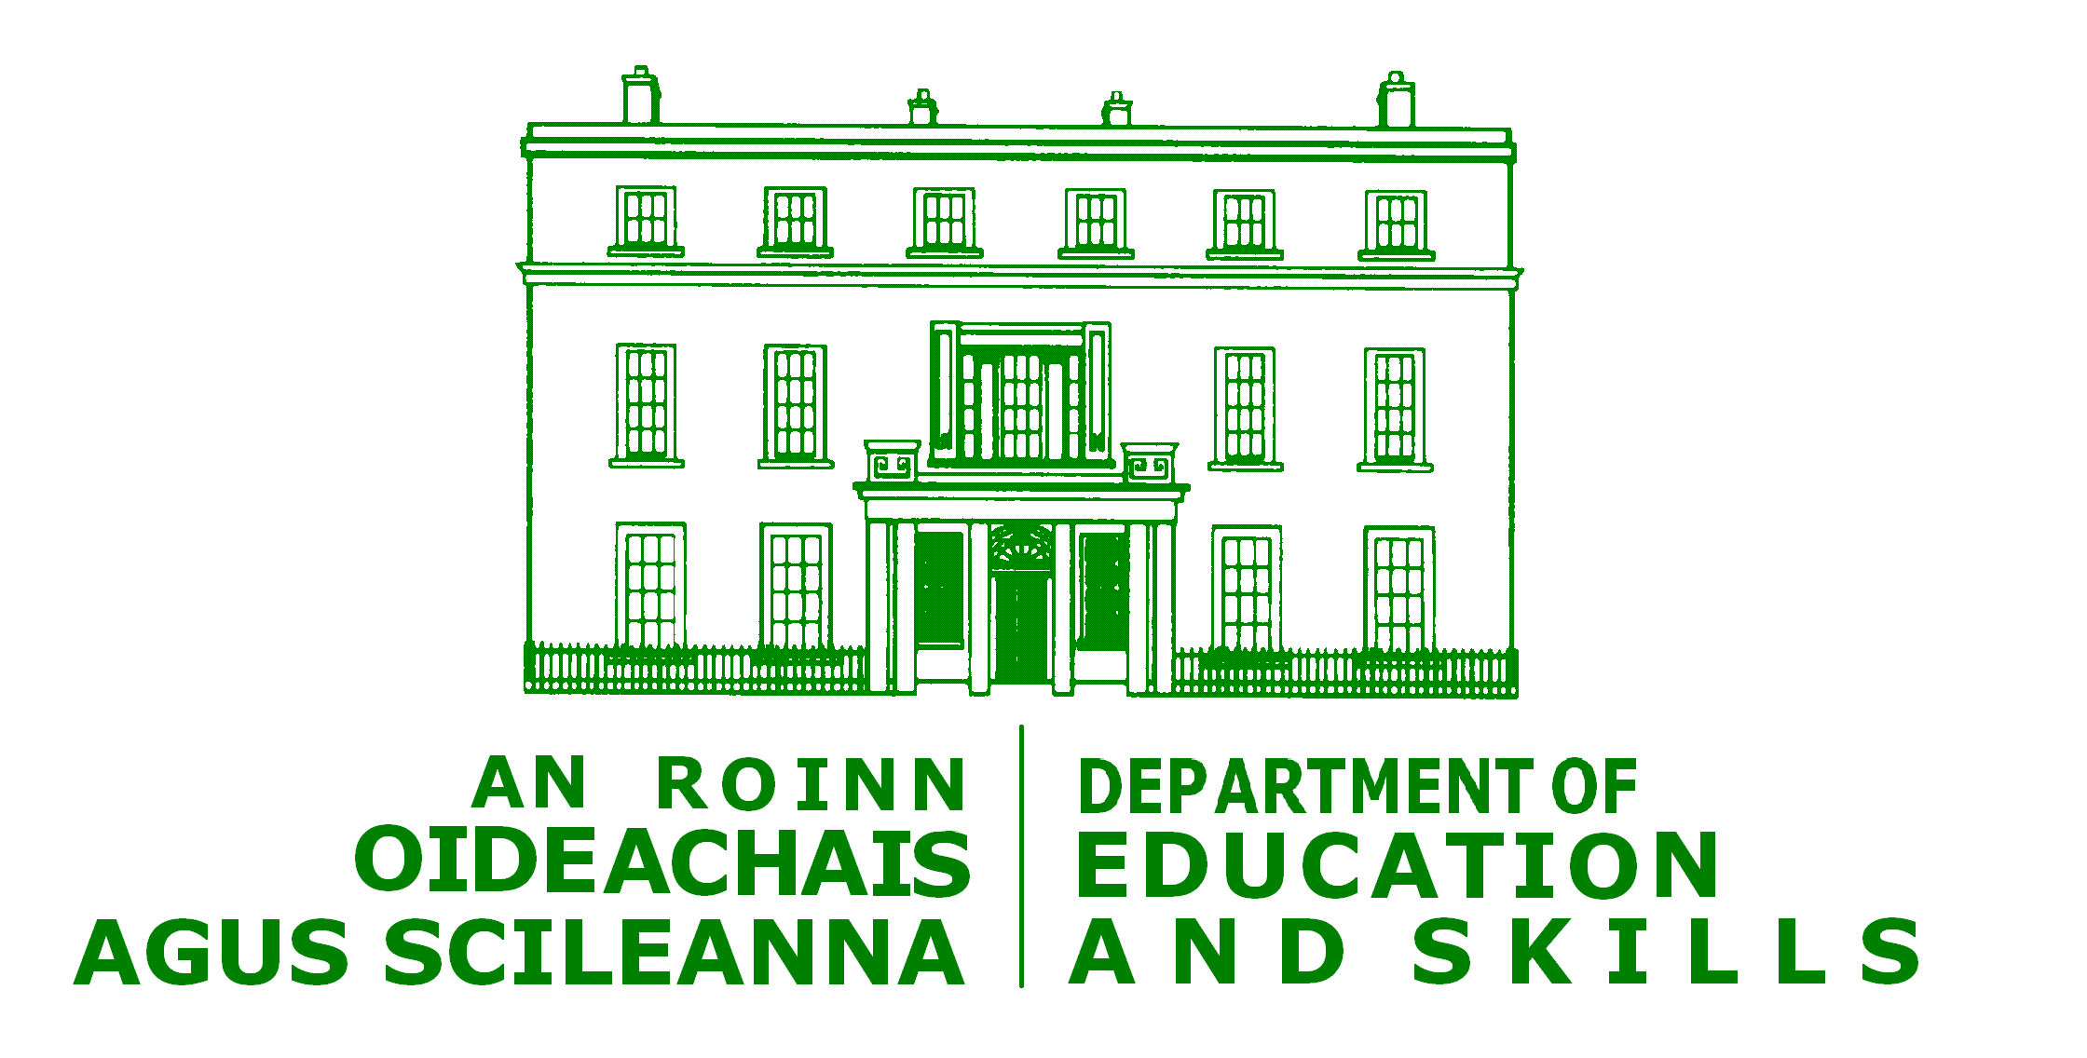

The Government of Ireland International Scholarships awarded by the Department of Education and Skills of Ireland

Please consult the Terms and Conditions of the scheme, complete this application form in accordance with the instructions and check that you have included the following.

- Appropriately sealed and signed references from two □
academic referees

- Copies of degrees or diplomas □

- Curriculum Vitae (in English) □

- Certificate of Health □

- Letter of invitation from Host Institution

- A recognised certificate testifying to the student’s □
knowledge of English and/or Irish

- Copy of passport page with photo id □

Government of Ireland International Scholarship

PHOTO
Attach recent passport size photo:

Surname/  Family name: | _______________________________________________
First name: | _______________________________________________
Note: Please also print your name on the back of photograph before affixing to application form)

Date of Birth: | _______________________________________________
Place of Birth: | _______________________________________________
Nationality/  citizenship: | _______________________________________________
Permanent home address: | _______________________________________________
 | _______________________________________________
 | _______________________________________________
Mailing address (if different): | _______________________________________________
 | _______________________________________________
 | _______________________________________________
Telephone: | _______________________________________________
Mobile number: | _______________________________________________
E-mail: | _______________________________________________
Academic Qualifications

Academic Qualification | Name of educational institution | Overall Grade |  | Duration of course
Please enclose copies of degree certificates or diplomas
Professional title: | _______________________________________________
Are you currently a: | PhD student  A post doctoral student
Please enclose confirmation of your current status
Please complete details of the host institution in Ireland:

Name of institution: | _______________________________________________
Department/School/  Faculty: | _______________________________________________
Study Programme/  Research: | _______________________________________________
Contact person: | _______________________________________________
Telephone number: | _______________________________________________
Mobile number: | _______________________________________________
E-mail: | _______________________________________________
Please describe your proposed study/research project in Ireland
(use a separate sheet if necessary)
Title of Project: | _______________________________________________
 | _______________________________________________
Summary:
Have you ever held a scholarship from the Government of Ireland or its agencies before |  |  | Yes No
Have you applied for or received other funding (in Ireland or elsewhere) for this project |  |  | Yes No
If the answer to either of the above two questions is yes, please provide details below.
Declaration
I declare that the above particulars are correct and understand that the Terms and conditions apply.
Signature: | _______________________________________________
Date:

